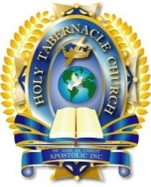
HOLY TABERNACLE CHURCH

INTERNATIONAL BIBLE COLLEGE

Student Registration Form

*New Students Only*

Personal Information
Last Name First
Student ID  N/A | Mailing Address (Street)
Phone | City, State, Zip, Country
Date of Birth | Email Address
School Information
School ID  Dorchester, MA - HTIBC | School Name  Holy Tabernacle Church International Bible College
School Phone  617-429.9028 | Mailing Address (Street)  70 Washington Street
School Chancellor  Bishop Dr. Arthur F. Jack | City, State, Zip, Country  Dorchester MA 02121
School Dean  Angelia Jack | School Email Address  htcibc@yahoo.com
Payment Method
On Line Payment Method | www.holytab.org

For HTCIBC Use Only
Member School  Dorchester MA - HTIBC | Amount Paid:  $25.00

Angelia Jack, Dean

